**Lesson 3 Demo 3**

**Understanding the Components of Kubernetes Cluster**



Steps to be followed:

1. Executing basic commands of etcd-server
2. Executing basic commands of kube-controller-manager
3. Executing basic commands of kube-scheduler
4. Executing basic commands of kubelet
5. Executing basic commands of kube-proxy
6. Listing the default pods in a cluster
7. Fetching containers from docker

**Step 1: Executing basic etcd commands**

1. On the **master** node, run the following command to install **etcd-server**:

***sudo apt install etcd-server***

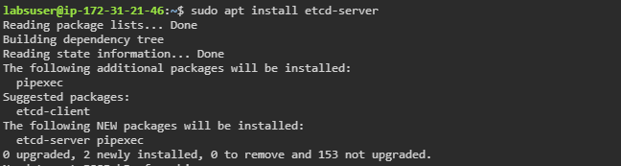

1. Check the etcd version using the following command:

***etcd --version***

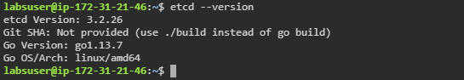

1. Check the etcd server by passing the **--name** flag

***etcd --name check***

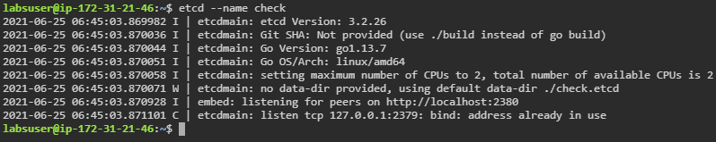

1. Use the **--help** flag to check the other commands

***etcd --help***

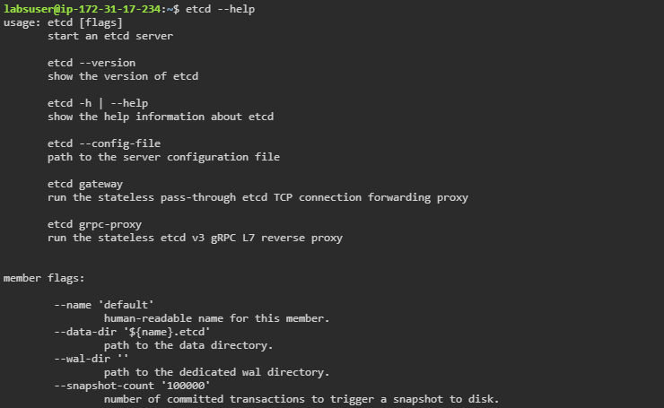

**Step 2: Executing basic commands of kube-controller-manager**

1. Type the following command to install kube-controller-manager:

***sudo snap install kube-controller-manager***





1. Verify the installation with the following command:

***kube-controller-manager --version***



1. Use the **--help** flag to check the other commands

***kube-controller-manager --help***

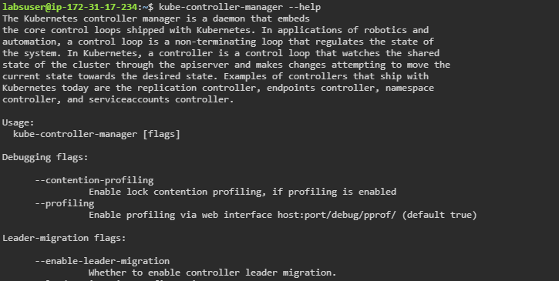

**Step 3: Executing basic commands of kube-scheduler**

1. Type the following command to install **kube-scheduler**:

***sudo snap install kube-scheduler***





1. Type the ***--help*** flag to check other options

***kube-scheduler --help***

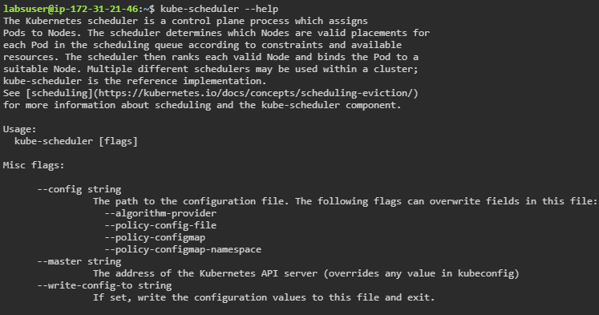

1. Check the kube-scheduler version using the **--version** flag

***kube-scheduler --version***



**Step 4: Executing basic commands of kubelet**

1. Check the kubelet version using the following command:

***kubelet --version***



1. Use the following command to check other flags:

***kubelet --help***

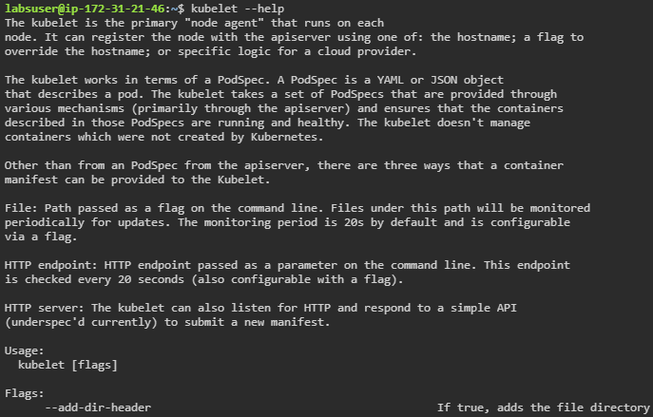

1. Start kubelet using root access

***sudo kubelet***

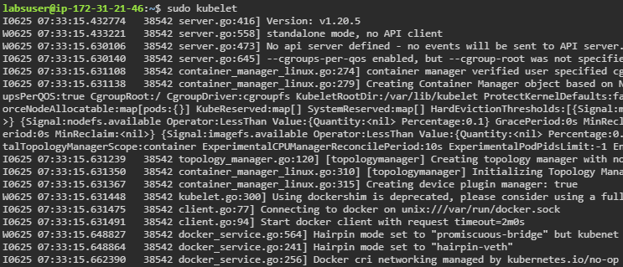

| **Note:** By default, it is accessible to the root users and user groups can be added. |
| --- |

1. Use the following command to write logs to their native severity level:

***kubelet --one-output***

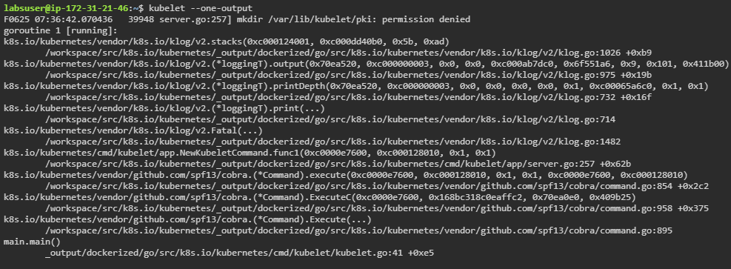

**Step 5: Executing basic commands of kube-proxy**

1. On the **master** node, install kube-proxy

***sudo snap install kube-proxy --classic***

1. Use the following command to check whether **kube-proxy** is successfully installed or not

***kube-proxy --version***

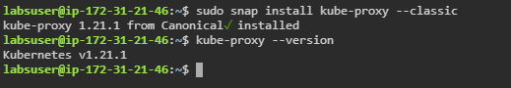

1. Use the –help flag to see all options of kube-proxy command

***kube-proxy --help***

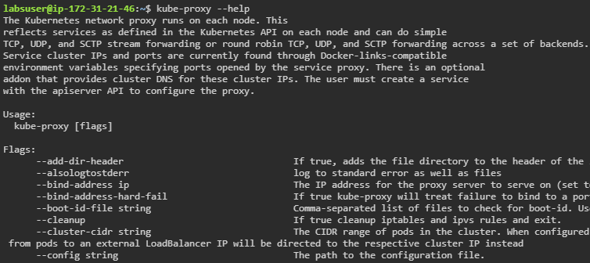

**Step 6: Listing resources in a cluster**

1. Use the following command to get all the pods in a cluster:

***kubectl get pods -A***

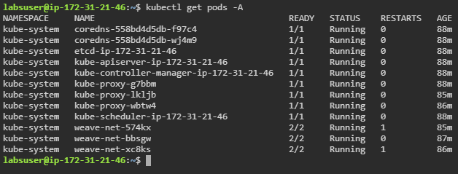

1. Use the following command to fetch all replica sets:

***kubectl get rs -A***

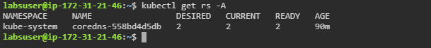

1. Use the following command to fetch all the deployments in a cluster:

***kubectl get deployments -A***

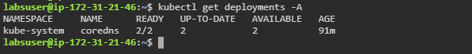

1. Use the following command to get all the services in a cluster:

***kubectl get svc -A***

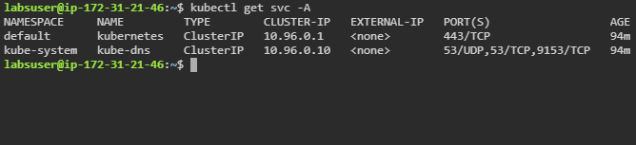

**Step 7: Fetching containers from docker**

1. Use the following command to list all the docker containers:

***docker ps***

